

***Hydropower Generation Under Climate Change***

**Bogazici University**

**Department of Industrial Engineering**

**Graduation Project**

**2019**

**Supervisor**

**Prof. Dr. Gürkan KUMBAROĞLU**

**Group Members**

**Sinan DEMİRHAN**

**Coşkun UYAR**

**Şeyma SARIDOĞAN**

**ABSTRACT**

**HYDROPOWER GENERATION UNDER CLIMATE CHANGE**

Although Turkey is a country rich in energy resources, it imports energy from external sources to meet energy needs.Hydraulic energy is one of the important renewable and clean energy sources and its importance is increasing. Hydroelectric energy potential in Turkey should be determined and the potential of energy must be used in the most efficient manner. Changes in average weather conditions have made climate change an important factor affecting our daily lives. The change in temperature and precipitation due to climate change will affect the existing hydrological situation, and as a result, hydroelectric production will change. Ataturk dam in Turkey having the largest hydroelectric power dam is. In this study, the effect of climate change on hydroelectric production in the Atatürk dam was observed. In this study, we used the soil and water assessment tool (SWAT) integrated with geographic information systems (GIS).

In the ARCSWAT tool, we observed climate change scenarios and observed changes in flow in the Atatürk Dam region. A decrease in precipitation will cause a negative impact on hydroelectric generation. Precipitation directly affects the flow for rivers where dams are fed. It was observed that the flow data will be decreased by approximately 2% in the future.The decrease in water flow in the river feeding the dam will decrease the production of hydroelectric power. In the second phase of the study, the BUEMS model has been used to observe the impact of this decrease in hydroelectric production to Turkey's economy and CO2 emissions. It is aimed to minimize the system cost by using optimization technique in BUEMS model.

**ÖZET**

İKLİM DEĞİŞİKLİĞİ ALTINDA HİDROELEKTRİK ÜRETİMİ

Türkiye, enerji kaynakları bakımından zengin bir ülke olmasına rağmen, enerji ihtiyaçlarını karşılamak için dış kaynaklardan enerji ithal etmektedir. Hidrolik enerji, yenilenebilir ve temiz enerji kaynaklarından biridir ve önemi giderek artmaktadır. Türkiye'deki hidroelektrik enerji potansiyeli belirlenmeli ve bu enerji potansiyeli en verimli şekilde kullanılmalıdır. Ortalama hava koşullarındaki değişiklikler, iklim değişikliğini günlük hayatımızı etkileyen önemli bir faktör haline getirmiştir. İklim değişikliğine bağlı olarak sıcaklık ve yağış değişimi, mevcut hidrolojik durumu etkileyecek ve sonuç olarak hidroelektrik üretimi değişecektir. Türkiye'nin en büyük hidroelektrik enerji barajına sahip olan Atatürk barajıdır. Bu çalışmada, Atatürk barajında ​​iklim değişikliğinin hidroelektrik üretimi üzerindeki etkisi gözlenmiştir. Bu çalışmada coğrafi bilgi sistemleri (GIS) ile bütünleşmiş toprak ve su değerlendirme aracını (SWAT) kullandık.

ARCSWAT aracında, iklim değişikliği senaryolarını ve Atatürk Barajı bölgesinde akıştaki değişiklikleri gözlemledik. Yağıştaki bir düşüş hidroelektrik üretimi üzerinde olumsuz etkiye neden olacaktır. Yağış doğrudan barajların beslendiği nehirlerin akışını etkiler. Akış verilerinin gelecekte yaklaşık% 2 oranında azalacağı görülmüştür. Barajı besleyen nehirdeki su akışındaki azalma, hidroelektrik enerji üretimini azaltacaktır. Çalışmanın ikinci aşamasında, BUEMS modeli hidroelektrik üretimindeki bu düşüşün Türkiye'nin ekonomisine ve CO2 emisyonlarına etkisini gözlemlemek için kullanılmıştır. BUEMS modelinde optimizasyon tekniğini kullanarak sistem maliyetini minimize etmek amaçlanmaktadır.

TABLE OF CONTENTS

ABSTRACT……………………………………………………………...............………………ii

TABLE OF CONTENTS…………………………………………………………...............…..iii

1. INTRODUCTION 1

1.1. A summary of the IE problem handled 1

1.2. A short overview of identification, analysis and solution methodologies 1

1.3. Followed steps 2

1.4. A brief summary of conclusions 2

2. PROBLEM DEFINITION, REQUIREMENTS, AND LIMITATIONS 3

2.1.Problem Definition 3

2.2 Understanding the Problem 4

2.3.Constraints and Environmental Issues 7

2.3.Context Diagram 8

2.4.Performance criteria 8

3. ANALYSIS FOR SOLUTION/DESIGN METHODOLOGY 9

3.1. Literature overview 9

3.2. Materials and method 11

3.2.1. Materials and modeling software 11

3.3.Forecasting 13

4.DEVELOPMENT OF ALTERNATIVE SOLUTIONS 19

4.1 Explanation of the BUEMS Model 19

4.2 Construction of the BUEMS Model 19

4.2.1 Technologies and Parameters 19

4.2.1.1. Supply Technologies 19

4.2.1.2. Energy Conversion Technologies 20

4.2.1.3. Demand Technologies 22

4.2.2 Variables 23

4.2.3 Equations and Constraints of the model 24

4.3.Pumped Hydro Storage - Hybrid Dams 28

4.4.Development of Alternative Solutions 29

4.4.1.Case 1: 29

4.4.2.Case 2.1: 29

4.4.3.Case 2.2: 29

4..4.Case 3.1: 29

4.4.5.Case 3.2: 29

5.COMPARISON OF ALTERNATIVES AND RECOMMENDATIONS 30

6.SUGGESTIONS FOR A SUCCESSFUL IMPLEMENTATION 33

7.CONCLUSION AND DISCUSSION 34

# INTRODUCTION

## 1.1. A summary of the IE problem handled

Among alternatives for energy generation, hydroelectricity is the most lucrative because of the renewable, low emissions and long service life of the infrastructure. Continuing to meet the needs of the population growth in Turkey needs more hydropower production. Although the hydroelectric sector is making a significant effort to deal with today's increasing world energy demands, this is a difficult situation because of climate change. Climate change is a major threat on the reliability of electricity supply, especially in countries like Turkey where hydroelectricity constitutes an important source of energy production and is dependent on the availability and variability of water resources. Temperature fluctuations, precipitation patterns, floods and droughts are the most important signs of climate change, which have a strong impact on river systems and thus affect hydroelectric production. We observed the impact of climate change on hydropower generation and the cost of this influence on Turkey's economy. At the same time monitoring of the changing CO2 emissions. Climate change will reduce the amount of water in the basin decrease in hydroelectric production in the dry season relating thereto will also have negative repercussions on the economy of Turkey. If there is not enough electricity production in hydroelectric power plants will become dependent on foreign supplies of energy to meet the needs of Turkey.

To assess climate change impacts on hydropower generation systems, a simple approach assumes that the current hydropower generation system may only be limited by water availability and that if water supply reduces, the hydropower systems will reduce generation and vice versa.

## 1.2. A short overview of identification, analysis and solution methodologies

As a result of the literature research, we have clearly defined the framework of our problem and carefully selected the steps we should follow. In our study, we decided to do based on Atatürk dam and narrowed our field of work. As the Atatürk dam was fed by the Euphrates, we were able to observe the effects of climate changes on the river and the impact on the hydropower production, so we used the Arcswat tool. Arcswat tool is a GIS based program. We've created scenarios by entering all of our work, such as soil, precipitation and wind, and Arcswat has provided us with a lot of data related to that area. As it is the flow data that is important to us, we have focused on the flow data. We have identified six important strategic points from the Atatürk Dam region and we have observed the effects of change in different points because these points are independent and different points. The first phase of our study consists of this, and we observed a decrease in flows as a result of climate change in this first stage.

## 1.3. Followed steps

Using the flow data obtained from Arcswat, we predicted the future. We used the ARIMA method to make this prediction. We observed that this will increase the flow amounts by predicting the future with this method. As a result of the forecast, we obtained the percentage of annual precipitation. We used the percentage of annual rainfall change in the BUEMS model. BUEMS model is established according to Turkey's energy system. It is used in optimization studies for energy sector. Because of the long-term future forecasts for BUEMS model we used based on the annual precipitation change in our hands, we observed changes in precipitation Turkey's economy and the impact of CO2 emissions. The reason for using the BUEMS model was to observe the impacts of climate change that we achieved until then. We have added climate change to declining hydropower generation in Turkey's economy as the impact of hydropower production to be used in adverse situations that constitute pump storage technology BUEMS model. Thus, we aimed to turn losses into earnings.

## 1.4. A brief summary of conclusions

Optimization of Turkey’s energy resources is a crucial optimization problem. Objective function is minimizing cost. At the end of the study effects of climate change to the optimization of Turkey’s energy resources will be evaluated. In this study, we observed the change in flows using Arcswat tool in the first stage. We created two scenario, we have observed that the flows are decreasing by almost 2% per year in Scenario 1 and 3% in Scenario 2 per year. We used the BUEMS model to observe the effect of this decrease in annual rainfall on hydroelectric generation. First, we have run the model without making any changes. Then, we add Scenario 1 and Scenario 2 results respectively. We add 2% to the effect of the decrease in flow BUEMS tables and will be lost to Turkey, we calculate the price of 152.9061 million dollars. We add 3% to the effect of decrease in flow BUEMS tables and will be lost to Turkey, we calculate the price of 222.5454 million dollars.

In the second stage, we added pump storage technology to the BUEMS model, a new technology. When we add new technology Scenario 1 (almost 2% flow reduction per year), pump storage tech is not profitable due to high investment cost.Optimization of energy demand with regular dams cheaper than hybrid ones (with pump storage). If we add new technology Scenario 2 (almost 3% flow reduction per year), pump storage tech is profitable.Optimization of energy demand with hybrid dams (with pump storage) 33.0946 million dollars cheaper than regular ones.

# PROBLEM DEFINITION, REQUIREMENTS, AND LIMITATIONS

## 2.1.Problem Definition

Together with population growth, urban development and industrialization, energy consumption in the world is increasing day by day. World population is expected to reach 9 billion with an increase of 1.6 billion by 2040. This allows more people to supply energy necessity. Although energy demand is different in each country, it is continuously increasing in global scale. Increasing energy investments in parallel to meet this growing demand is required. The role of hydroelectric power generation is very important for the economic use of water resources.

Hydroelectric energy should not dependent on foreign sources because it should be produced using country resources. The electricity consumption of a country is an indicator of the development of that country. As of the end of 2016, our country's electricity production is 273.4 billion kWh and its consumption is 278.3 billion kWh. Our country's annual electricity energy consumption growth rate was realized as 5.4% in the last 15 years and our electricity consumption, which was 132.6 billion kWh in 2002, doubled in 2016, 278.3 billion kWh. As of the end of 2016, 184,889 GWh of our electricity production with 273,387 GWh was obtained from thermal power plants, 67,268 GWh from hydroelectric power plants and 21,230 GWh from other renewable energy sources. 20% of the total energy production in Turkey is provided by hydropower (2016). As of the end of 2016, our electricity installed capacity increased from 31.846 MW in 2002 to approximately 78.497 MW. With the power plants commissioned in 2016, a capacity of 5.899 MW was added to the installed capacity of our country. In the last 15 years from 2002-2016, an average annual power increase of 7.1% was realized.

Temperature fluctuations, precipitation patterns, floods and droughts are the most important signs of climate change, which have a strong impact on river systems and thus affect hydroelectric production. It will reduce the amount of water in the basin decrease in hydroelectric production in the dry season relating thereto will also have negative repercussions on the economy of Turkey.

Atatürk Dam (Table 1) is located on the Euphrates River between Adıyaman and Şanlıurfa and is intended for energy and irrigation purposes. The dam, which was completed in 1992, has 8 turbines and has a height of 169 meters. Hydrological studies show the average annual input flow of the Atatürk Dam at 843 m³ / s.

|  |  |
| --- | --- |
| Basic design specifications of hydropower plant | |
| Design feature | Specification |
| Installed capacity | 2400 MW |
| Number of turbines | 8 |
| Production capacity per year | 8 900 GWh |
| Production per year | 6 000 GWh |
| Average water flow per year | 26 654 billion m3 |
| Maximum reservoir volume | 48,7 billion m3 |

**Table 2.1. Physical properties of the Atatürk dam**

## 2.2 Understanding the Problem

This project examined the Atatürk dam. First, 6 strategic stations(Figure 2.1) were selected in the region where Atatürk Dam was located and climate changes in these stations were observed. While selecting these 6 stations, the points that can make a difference between the important places on the Euphrates River that feed the Atatürk dam have been selected. It can be seen that there are significantly important differences in average rainfalls between those selected station(Figure 2.2).

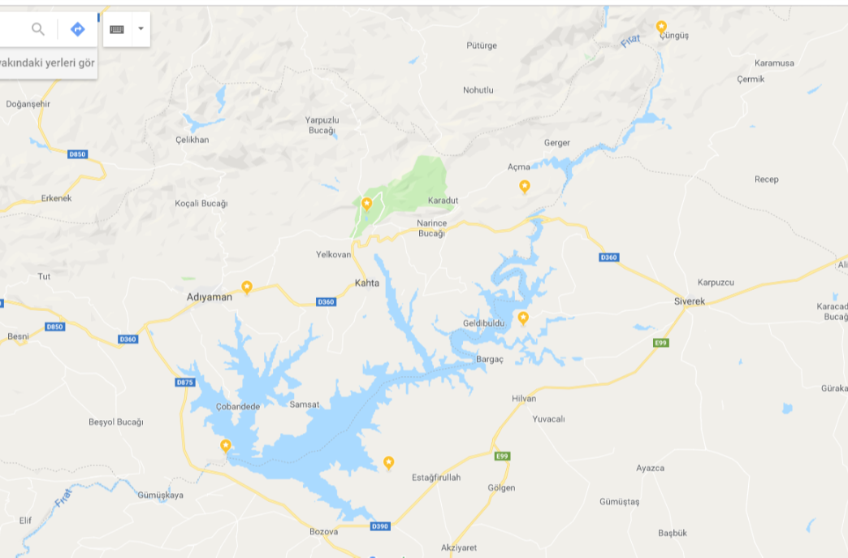**Figure 2.1. Selected 6 stations in Atatürk dam region**

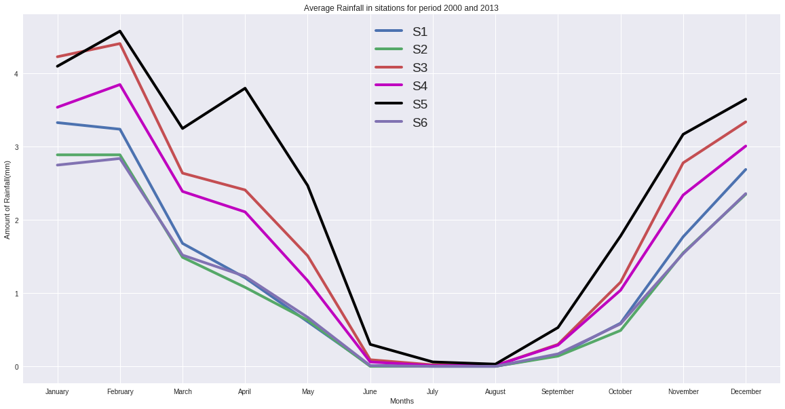

**Figure 2.2. Selected stations’ average rainfall**

In the problem identification process, firstly literature research was made. After the literature research, Arcswat tool was used in order to examine changes in flow for Atatürk Dam. In this study, spatial, meteorological, and river flow data is essential for developing a SWAT model for the Ataturk Dam and its feeder stream Fırat River. The monthly time series of hydrometeorological data for the period of certain years taken into consideration for numerical solution based on their availability.

The hydropower generation is a function of the flow discharge, head, and density of water. The gross hydropower generation in watts can be calculated as follows:

**E = p*g*Q*Δh*n**

* + - E is energy,
    - p is density of water,
    - g is gravity,
    - Q is flow discharge,
    - h is difference of elevations,
    - n is efficiency.

SWAT database files adjusted for the case of the Ataturk Dam, as application of SWAT to other areas demands customization regarding the local conditions. To this end, a new database of soil type, crop, land use, and weather was created. The development of the model initially required automatic watershed delineation and weather inputs. The study area was divided into sub-basins linked with the stream network, and smaller units were named as HRUs, signifying an arrangement of land use, soil, and slope. This enabled the SWAT model to reflect differences in hydrological conditions along with land use and soil type, and in turn, enhanced the precision of load predictions and gave a better physical description of the water balance.

The daily time series of hydrometeorological data for the period of 34 years from 1979 to 2013 were taken into consideration for numerical simulation based on their availability.

Six stations were selected to obtain the weather information and for analyzing their effects to the production of hydropower energy. By taking six different stations (Table 2) to observe them according to their temperatures and precipitations, determining the one that contributes much more benefit to the production will be easily seen.

|  |  |  |  |  |
| --- | --- | --- | --- | --- |
| Station | Site name | Elevation(m) | Latitude | Longitude |
| HES 1 | Atatürk Dam,Diyarbakır | 530 | 37,486823 | 38,312526 |
| S1 | İpekli, Adıyaman | 801 | 37,7601 | 38,35634 |
| S2 | Karaköprü, Şanlıurfa | 567 | 37,459245 | 38,665721 |
| S3 | Kahta, Adıyaman | 576 | 37,902855 | 38,61708 |
| S4 | Gerger, Adıyaman | 1233 | 37,93269 | 38,96121 |
| S5 | Cüngüş, Diyarbakır | 1375 | 38,20581 | 39,26067 |
| S6 | Siverek, Şanlıurfa | 601 | 37,706913 | 38,956243 |

**Table 2.2. Physical properties of selected stations’ in the Atatürk dam region**

## 2.3.Constraints and Environmental Issues

We will use the soil and water assessment tool (SWAT), integrated with geographic information systems (GIS), to evaluate climate change impacts on hydropower generation for a selected plant in Turkey and to develop a model for simulating the water flow of the relevant basin and computing the hydropower impacts of a changed climate.For our Project, limitations and restrictions is that we have difficulty in finding data that we want to and for these data are either in very rarely sites or not open source.When we want to find data ,especially for our country,it is very difficult so we find data for our country in the foreign resources. Additionally, ArcSWAT tool is not well documented. We needed more tutorial about ArcSWAT when we used it. The most effectively limitation is that climate change is complex interaction. Because the effects of climate change have a lot of unknown parameters. When we observed the effects of climate change on hydropower generation, we do not forget that climate change is very comprehensive. You can not precisely seperate the causes of climate change.

## 2.3.Context Diagram

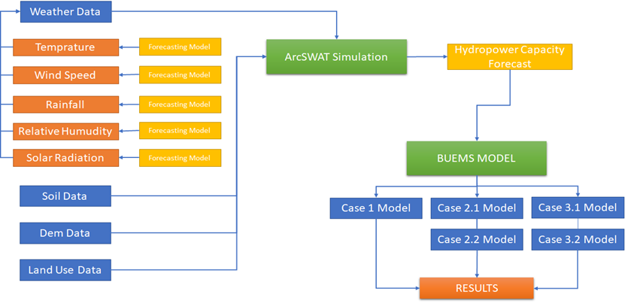

**Figure 2.3. Contex Diagram**

We used Weather Data, Soil Data, Dem Data and Land Use Data for ArcSWAT simulation. Weather Data consist of Temperature, Wind Power, Rainfall, Relative Humidity and Solar Radiation. These data were forecasted and used for ArcSWAT tool. After the starting ArcSWAT tool we obtained flow data. Also, we obtained many kinds of data but we just use flow data. Flow data entered to BUEMS and we create 3 basic cases in BUEMS. These cases gave us different results.

## 2.4.Performance criteria

To assess climate change impacts on hydropower generation systems, a simple approach assumes that the current hydropower generation system may only be limited by water availability and that if water supply reduces, the hydropower systems will reduce generation and vice versa. So, our performance criteria is the amount of water. We observed changes in flow data.

# 3. ANALYSIS FOR SOLUTION/DESIGN METHODOLOGY

## 3.1. Literature overview

Literature review was made to identify similar work done within the area. There are several studies conducted on climate change effects. Actually, the topic which is examined in this project is more specific than climate change effects because we interested in climate change effects on hydropower generation. However, to understand the problem, articles from different perspectives were also investigated.

Mohammad Mehedi Hasan and Guido Wyseure (1) interested in the impact of climate change on hydropower generation in Rio Jubones Basin in Ecuador. This study attempted to use the soil and water assessment tool (SWAT), integrated with geographic information systems (GIS), for assessment of climate change impacts on hydropower generation. This methodology of climate change impact modeling was developed and demonstrated through application to a hydropower plant in the Rio Jubones Basin in Ecuador. ArcSWAT 2012 was used to develop a model for simulating the river flow. The model parameters were calibrated and validated on a monthly scale with respect to the hydro-meteorological inputs observed from 1985 to 1991 and from 1992 to 1998, respectively.Numerical simulation with the model indicated that climate change could alter the seasonal flow regime of the basin, and the hydropower potential could change due to the changing climate in the future. Scenario analysis indicates that, though the hydropower generation will increase in the wet season, the plant will face a significant power shortage during the dry season.

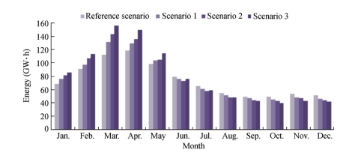

**Figure 3.1. Comparison of predicted average monthly hydropower generation in assumed climate change scenarios with that in reference scenario.** (Mohammad Mehedi Hasan and Guido Wyseure)

Petter Pilesjo and Sameer Sadoon Al-Juboori (2) interested in the effects of climate change on hydroelectric power in Dokan in Iraq. The aim of this study is to evaluate potential climate change impacts on hydropower in Dokan region, and to recommend various options to maintain optimum required water level to ensure full capacity of electricity generation throughout the year. A simple approach assumes that hydropower systems will reduce generation if water supply reduces, and vice versa. The analysis of the approach was carried

out to convert changes in water resource availability to changes in electric hydropower generation.

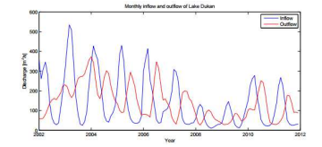

**Figure 3.2. A comparison between Inflow and Outflow of Dokan Lake during (2002 – 2012).(** Petter Pilesjo and Sameer Sadoon Al-Juboori (2))

In this study, we used ArcSWAT tool so we did our study based on the article the effects of climate changes on hydropower generation in Rio Jubones Basin in Ecuador. After selecting study area as Atatürk Dam we determined necessary information about this area because we used these decisive information for ArcSWAT tool. We observed in these article forecasting method is usually used for climate change effects analysis. Thus, we forecast flow data for future and we analyzed climate changes effects according to forecasting results.

## 3.2. Materials and method

### 3.2.1. Materials and modeling software

In this study, spatial, meteorological, and daily river flow data were prerequisites for developing a SWAT model for the Atatürk Dam. The daily time series of hydrometeorological data for the period of 35 years from 1979 to 2013 were taken into consideration for numerical simulation based on their availability.

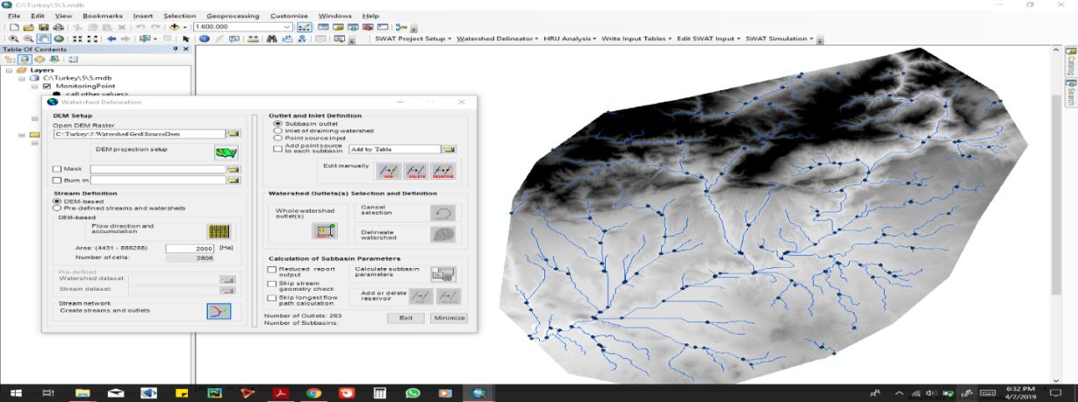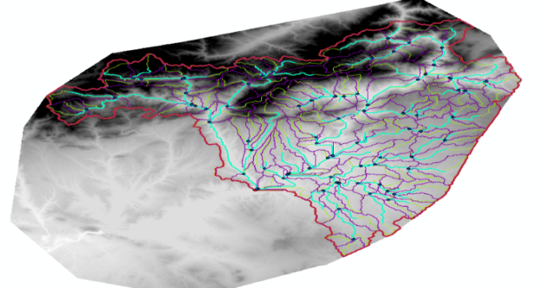

**Figure 3.3 Flow simulation Figure 3.4.Generated sub-basins**

SWAT necessitates meteorological data, consisting of daily rainfall, air temperature (minimum and maximum), relative humidity, and wind speed, as weather inputs. In this study, these data are derived from open source site which is called https://globalweather.tamu.edu/. For the spatial data, the WGS_1984_UTM_Zone_37N coordinate projection was used which resresents area of Turkey. The ArcView GIS 10.2 interface for ArcSWAT 2012 was chosen as a tool in this study.

3.2.Arcswat simulation for years between 1990 and 2013.

In this study, the soil and water assessment tool (SWAT) model, which is basically a river basin model, was used to simulate the river flow. The tool anticipates the effects of management practices on water, sediment, and agrochemicals in large, complex basins with changeable soils, land use types, and management conditions, over extended periods of time. To simulate the physical process, the river basin may be split into a number of sub-basins(Figure 3.3).The whole dam basin was not able to splitted into sub basins because there is not current in the whole area so,the defined area was selected for splitting into subbasins(Figure 3.4).

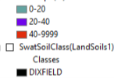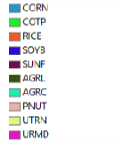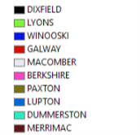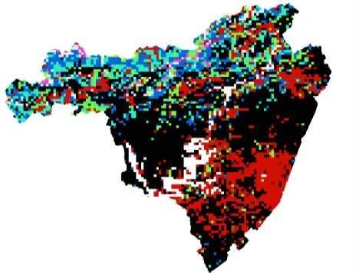 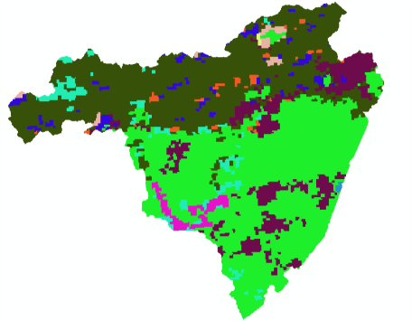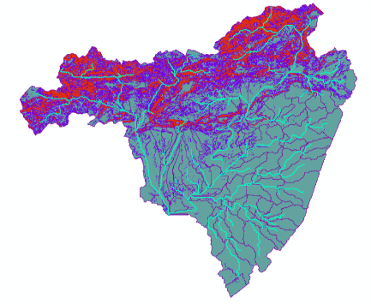

**Figure 3.5Soil use table Figure 3.6.Land use table Figure 3.7.Slope Definition table**

In the HRU(hydrological response units) analysis, Discrete land use patterns and Heterogeneous soil classes are observed in Atatürk Dam area. The arrangement of soil(Figure 3.5), land use(Figure 3.6), and slope definition tables(Figure 3.7) enables the SWAT model to reflect differences in hydrological conditions along with land use and soil type, and in turn,enhances the precision of load predictions and gives a better physical description of the water balance. It is essential to keep in mind that the HRUs were not spatially adjacent and they had clustered response units. The pixels generating an HRU may be stretched throughout the sub-basin. Basic prerequisites for building the model were achieved by defining weather input data. Files including daily weather information at six stations were specified in this model study.

The numerical simulation was performed for a period of 24 years from 1990 to 2013 with the SWAT model.The first five years (1990-1994) were considered as a warm-up period, allowing the model to make the hydrologic cycle fully functional and stabilize some initial model parameters. Since the model did not perform well in daily simulations, monthly data were used in this study.

In the Run Swat simulation part,we defined the first five years of our data as warm up period and after running the simulation we have got the results.The flow data is the most important data for us from this simulation and we use that as the base data because we know that if the flow is high, the production capacity will be high and if the flow is low,then the production capacity will be low for power plants in that specific area.When we devided the DEM file into sunbasins,153 sub-basins is formed and the sub-basin 135 is the most important sub-basin for us because in that sub-basin all flows came together and also the flow rate in that sub-basin shows the total flows which accumulated in that sub-basin.

The Figure 3.8. shows the flow rates between years 1995 and 2013 in the sub basin 135.It can be seen from this time series data that there is a seasonality because the flow rates decrease in the summer months and increase in the winter months. This situation leads to production to be low in the summer months and high in the winter months.

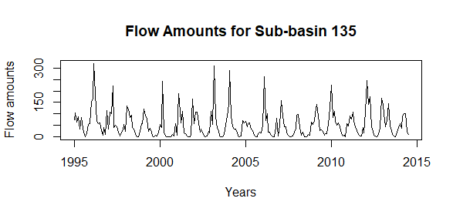

**Figure 3.8. Flow Amounts for Sub-basin 135**

The sub basin 135 is the basin that all flows come together in this basin and you can see the flow amounts for sub basin 135.In this situation it can be thought that is there a relationship between the production amounts for Atatürk Dam and the flow amounts for our basin. We can see this from the correlation coefficient which corresponds to the correlation between production of Atatürk hyroelectric power plant and flow amounts in the sub-basin 135.When we look at the correlation, we see that correlation between those two independent variables are 0.67 and it is a highly reasonable value to believe that there is a relationship between production and flow rates.

### 3.3.Forecasting

So what can we do to understand and see the climate change effects on the hydropower production rates.We have rainfall data,temperature data,relative humidity data,solar radiation data and wind speed data(Figure 3.9) from year 1979 to 2013.And we observed a little decreasing or increasing trends on those data.Will these trend effect the the future values of those data or not.It is not known but it is known that if we make 12 years ahead forecasting for these data then we can give these forecasted values again to the Arcswat Simulation and we can get the decreasing or increasing percentages per years in the flows.

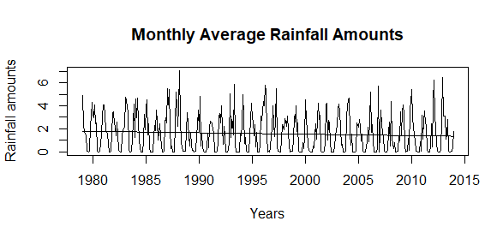 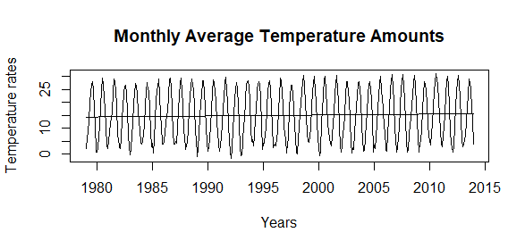

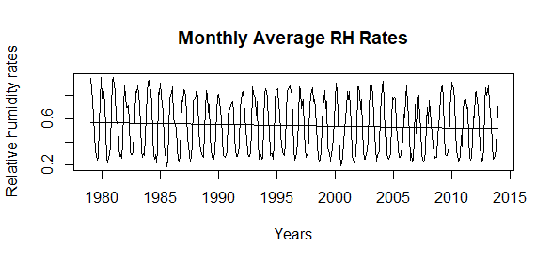 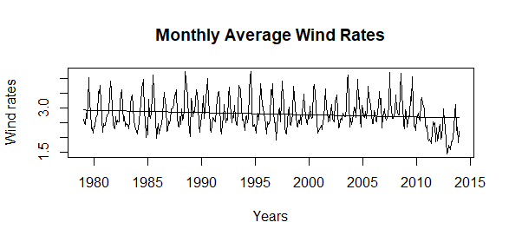 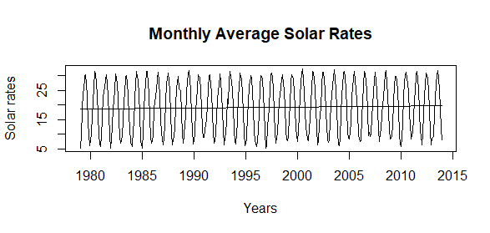

**Figure 3.9. All data that we have is between years 1979 and 2013**

In the forecasting process,we firstly searched for whether ARIMA function is a good model for these data or not. To see the efficiency of model better,we partitioned all data into two parts as a training set and test set.Our train sets consists of years from 1979 to 2010 and our test sets consists of years from 2011 to 2013.Then by using auto.arima function in R, we found the best models whose MSE values are the least one in the train data and by using these founded models we forecast for years between 2011 and 2013 (Figure 3.10). For temperature,solar,relative humidity and wind speed forecasts we took very reasonable R-squared values in the test data(Table 3.1) so,we have concluded that these models are very reasonable models for these four data.

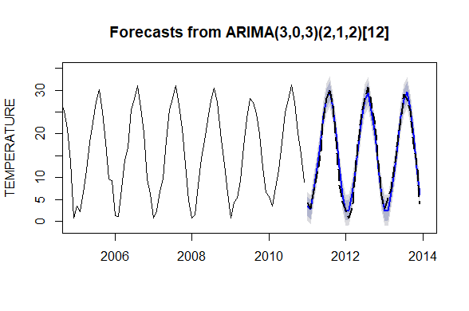 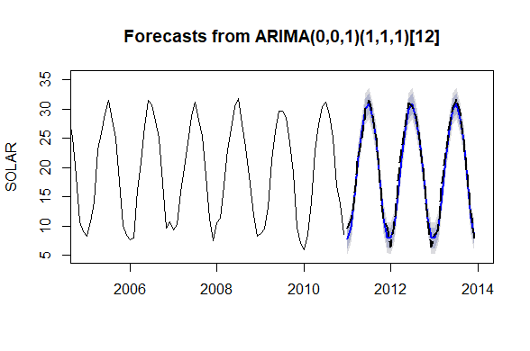

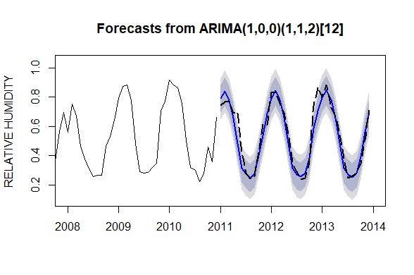 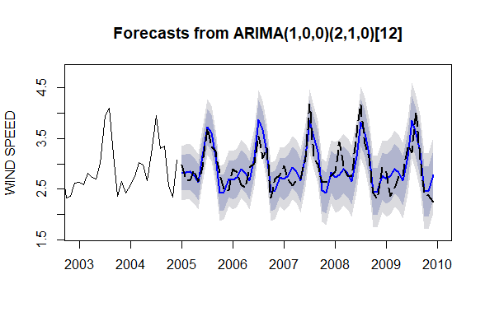

**Figure 3.10 Forecastings in the test data**

|  |  |  |  |  |  |
| --- | --- | --- | --- | --- | --- |
| ***DATA*** | ***THE BEST MODEL IN***  ***THE TRAIN SETS*** | ***SSE*** | ***SSR*** | ***SST*** | ***R-SQUARED*** |
| ***TEMPERATURE*** | ***ARIMA(3,0,3)(2,1,2)[12]*** | ***78.929*** | ***3198.2*** | ***3277.17*** | ***0.9759*** |
| ***SOLAR RADIATION*** | ***ARIMA(0,0,1)(1,1,1)[12]*** | ***37.95*** | ***2404.2*** | ***2442.1*** | ***0.984*** |
| ***RELATIVE HUMIDITY*** | ***ARIMA(1,0,0)(1,1,2)[12]*** | ***0.160*** | ***1.6607*** | ***1.8208*** | ***0.912*** |
| ***WIND SPEED*** | ***ARIMA(1,0,0)(2,1,0)[12]*** | ***1.9070*** | ***6.1306*** | ***8.0377*** | ***0.762*** |

**Table 3.1.Statical values on the test sets**

By using the best models in the train sets and also the reasonable models that gives very high r-squared value in the test sets,we forecasted for the next 12 years from 2014 to 2025 for all data excluding the rainfall data.We observed from the forecasted values that there is 0.5% increasing trend per year in the temperature data 0.12% per year increasing trend in the solar radiation data, 0.64% decreasing trend in the relative humidity data and 0.4% per year decreasing trend in the wind data(Figure 3.11).

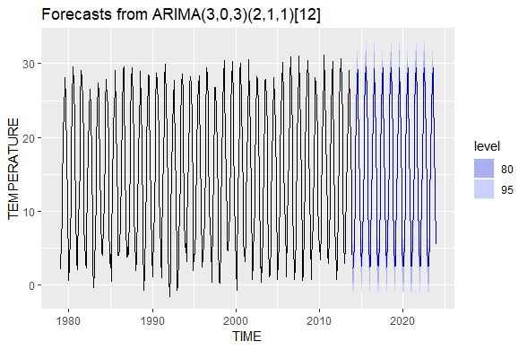 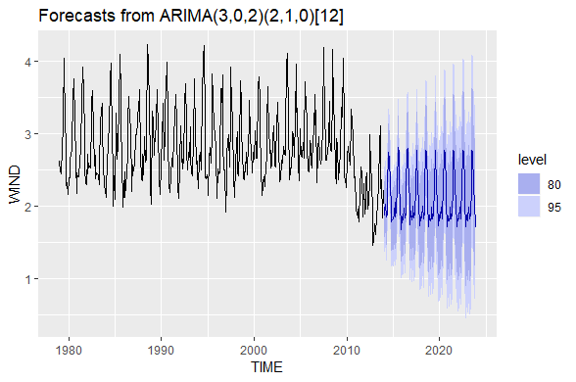

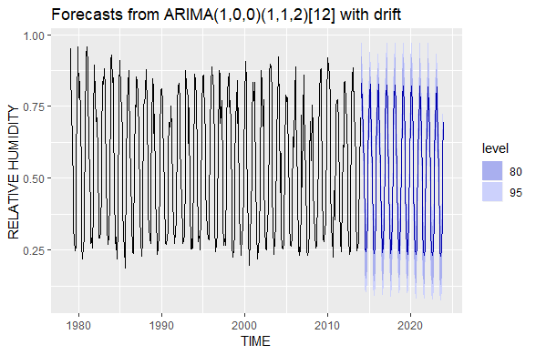 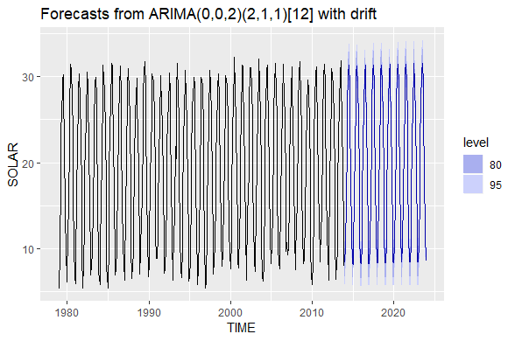

**Figure 3.11. Forecastings for 12 years ahead**

However, when we took years from 1979 to 2010 as train data we didn’t get a reasonable r-squared value in the rainfall data.It was 0.56 so because of this low r-squared value we tried a different way to find a high and reasonable r-squared value.In this strategy,we firstly took years up to 2001 as train set and the data after year 2002 as test set then took years up to 2002 as train set and after year 2003 as test set. We have done this strategy for all years up to 2012 by increasing train set 1 year and decreasing test set 1 year like in the Table 2.After that,we found the best fitted models in the train set and found the r squared values in the test set by forecasting with our best fitted models that we found in the train set.After we did this on the all test sets we calculated r-squared values for all of them(Table 3.3).

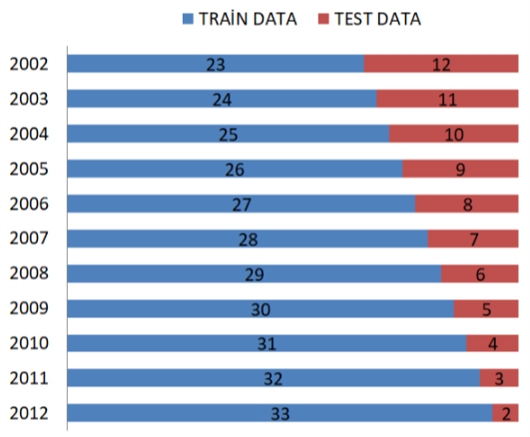

**Table 3.2.Train and test sets**

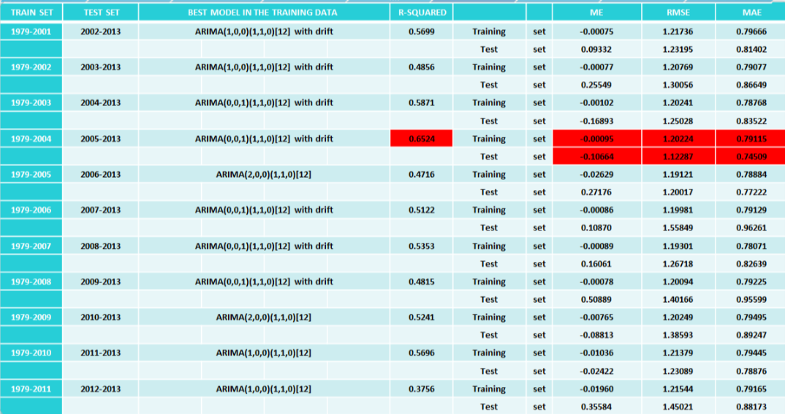

**Table 3.3. Statical values for all fitted models**

When we look at the table.We can see the years which corresponds train and test sets,best fitted models in the training sets,r-squared values on the test sets and some error types on the train and the test sets.It is seen from the table that taking years up to 2005 as train set and doing forecasts with that fitted model gives the best r-squared value.So,we admitted this model as our first scenario in forecasting the rainfall rates up to 2025.

By using this model ,we have done our forecasts up to 2025 using the train set for year up to 2005 and we observed 0.0872% decreasing per year. then we extracted the forecasted values from year 2014 to 2025(Figure 3.12).

When we have done rainfall forecasts in scenario 1 we didn’t include the trend and data points between year 2005 and 2013 so,in scenario 2 we added those variables also.By using the best fitted model in scenario 1 which is ARIMA (0,0,1)(1,1,0) with drift on the all rainfall data from 1979 to 2013 we forecasted rainfall values up to 2025.After forecasting, we extracted the forecasted values from year 2014 to 2025(Figure 3.13).

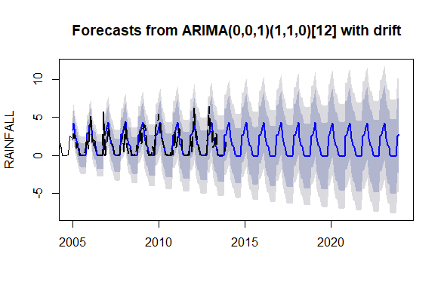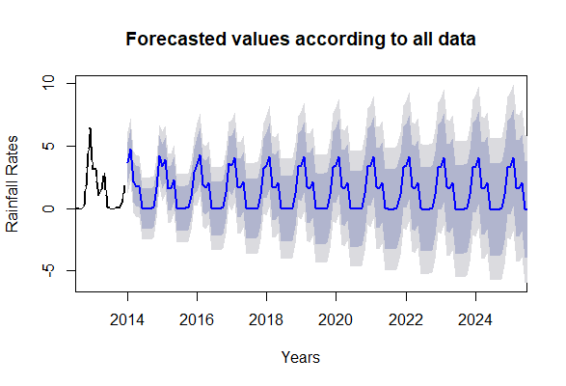 **Figure 3.12.** **Forecastings in Scenario 1 Figure 3.13** **Forecastings in Scenario 2**

According to our forecast results ,it is foreseen that there will be 0.872% yearly decrease in the rainfall amounts according to scenario 1 and it is foreseen that there will be 1.237% yearly decrease in the rainfall amounts according to scenario 2.The pecentage flunctuation in the other forecasted data can be seen also from the Table 3.4.

|  |  |  |
| --- | --- | --- |
|  | **SCENARIO 1** | **SCENARIO 2** |
| **Rainfall rates** | **0.872%** | **1.237%** |
| **Temperature rates** | **0.55%** | **0.55%** |
| **Relative Humidity Rates** | **0.64%** | **0.64%** |
| **Solar Rates** | **0.12%** | **0.12%** |
| **Wind Rates** | **0.4%** | **0.4%** |
| **Result in simulation** | **2.051%** | **3.072%** |

**Table 3.4.The forecasted pecentage flunctuation rates for five data**

After we have the forecasted values we gave them to the Arcswat simulation again and we got the flow results for years between 2014 and 2025.In the flow results,according to scenario 1 it is foreseen that there will be 2.051% decrease yearly in the flow amounts and according to scenario 2 it is foreseen that there will be 3.072% decrease yearly in the flow amounts.

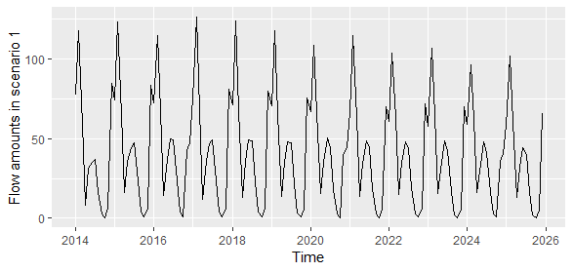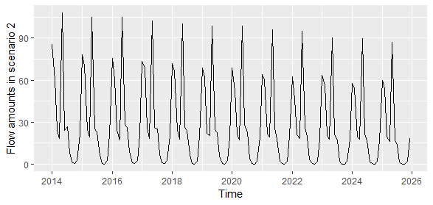

**Figure 3.14.** **Flow amounts in Scenario 1 Figure 3.15** **Flow amounts in Scenario 2**

As a consequence of forecasting part ,we have forecasted for all data types that we have and gave those forecasted values to the Arcswat simulation.After we have done this in 2 scenario,when the changes in the temperature,solar radiation, wind speed and relative humidity data kept constant, 2.051% yearly decrease in the flow amounts is foreseen for 0.872% yearly decrease in rainfall data and 3.072% yearly decrease in the flow amounts is foreseen for 1.237% yearly decrease in rainfall data.In the final flow results, it is seen 0.365%(1.237-0.872) yearly decreasing in the rainfall data results approximately 1% yearly decrease in the flow amounts.This situation shows us that for energy production in the [hydroelectric power plant](https://tureng.com/tr/turkce-ingilizce/hydroelectric%20power%20plant)s ,the rainfall amounts are very important variable and production rates ar very sensitive to the rainfall amounts.

# 4.DEVELOPMENT OF ALTERNATIVE SOLUTIONS

## 4.1 Explanation of the BUEMS Model

BUEMS is a linear optimization model which assesses different energy strategies and long-standing effects of investment alternatives. BUEMS is planned to imitate Turkish energy system and is built to satisfy the need for a countrywide model on behalf of local technology structure. The objective of the BUEMS is to minimize entire system cost, while meeting the energy demands and defining the main energy supply levels, subject to a set of restrictions over the predefined preparation prospect. An important benefit of BUEMS framework is that the model does not need a huge level of statistics. The relations, restrictions, goods groups and technologies in the model are simplified. GAMS programming language has been used to solve the model.

## 4.2 Construction of the BUEMS Model

There are dual elementary instruments in the BUEMS model which are technologies and commodities. The set of energy transporters combine of commodities that are produced or treated by technologies. There is overall amount of 209 energy carriers in the model which consist of coal, natural gas, petroleum, nuclear, hydropower, wind, solar, geothermal and hydrogen energy sources. The following sections explain technologies and variables in the BUEMS model.

### 4.2.1 Technologies and Parameters

Every procedure that changes one commodity into another is mentioned as a technology. There are three different kinds of technologies in the model which are linked to each other through energy sources.

### 4.2.1.1. Supply Technologies

These technologies present energy foundations into the system. Energy foundations can be provided nationally and externally. “Domestic Technologies” are classified into two subsections: “extracted (mining) technologies” and “renewable technologies”. On the other hand, imported resources are provided by “import technologies”. “export technologies” are also comprised in supply technologies. BUEMS model comprises fossil fuels and renewable energy foundations. Fossil fuels are coal, natural gas, oil, heavy fuel oil, light fuel oil, jet fuel and kerosene, whereas renewables are wind, solar, hydroelectric and geothermal energy. BUEMS model also comprises hydrogen as an energy source and nuclear power energy that needs uranium as an energy source.

|  |
| --- |
| **Supply Technologies** |
| Import Technologies |
| Mining Technologies |
| Renewable Technologies |
| Export Technologies |

**Table 4.1.The organization of energy resources**

Source levels are limited by yearly and cumulative limits. Yearly source bounds put limits on import and export activities. Similarly, these limits are used for renewable energy resources it is impossible to produce energy from renewables. Cumulative supply bounds, on the other hand, put limitations on the total supply of supply technologies over the entire planning horizon.

The main limits of supply technologies are specified below:

● bound_s_upper(s,t) : upper bound on the capacity of a supply technology

● bound_s_lower(s,t) : lower bound on the capacity of a supply technology

● bound_s_fix(s,t) : fix bound on the capacity of a supply technology

● cum(m,cm) : supply cumulative capacity

● decayr(m,t) : decay rate of a supply technology

● growthr(m,t) : growth rate of a supply technology

● scost(m,t) : supply cost

● envsep(m,t) : emission factor for supply technologies at period t

The role of these parameters to the model will be clarified in the equations section in detail.

### 4.2.1.2. Energy Conversion Technologies

An energy carrier is altered to another energy carrier by energy conversion technologies. Energy conversion technologies are divided into three subgroups.

|  |
| --- |
| **Energy conversion technologies** |
| Energy Conversion Technologies Electricity Generation Technologies |
| LTH Generation Technologies |
| Process Technologies |

**Table 4.2. Energy conversion technologies**

“Electricity Generation Technologies” produce electricity. “LTH Generation Technologies” produce LTH and “Process Technologies” produce remaining energy sources such as ethanol, methanol, coke and hydrogen.

The core parameters of energy conversion technologies are shown below.

● af (m,t) : annual availability factor of the technology m at period t

● baseload(e,t) : the highest percentage of the baseload power plants in total electricity generation:

● bound_p_fix(m,t), bound_p_upper(m,t) : annual fix and upperbounds on the capacity of a technology at period t

● bound_k_lower(m,t), bound_k_fix(m,t), bound_k_upper(m,t) : annual lower, fix and upper bounds on the activity of a process technology at period t

● bound_c_lower(m,t), bound_c_fix(m,t), bound_c_upper(m,t) : annual lower, fix and upper bounds on the activity of a conversion technology at period t

● bounds(b,t) : annual bounds on scenario constraints at period t

● ibond(m,t), ibondfx(m,t), ibondlo(m,t) : annual lower, fix and upper bounds on the investment of the technology m at period t

● capunit(m,t) : unit conversion factor between capacity and activity of the technology m at period t 23

● decay(m,t) : maximum capacity decay rate of the technology m between consecutive periods

● growth(m,t) : maximum capacity growth rate of the technology m between consecutive periods

● invcost(m,t) : investment cost per unit of new capacity addition of the technology m at period t

● edistinv(m,t) : unit investment cost for electricity distribution system of electricity generation technology at period t

● etraninv(m,t) : unit investment cost for electricity transmission system of electricity generation technology at period t

● dtraninv(m,t) : unit investment cost for LTH transmission system of LTH generation technology at period t

● dtranom(m,t) : unit O&M cost for LTH transmisson system of LTH generation technology at period t

● etranom(m,t) : unit O&M cost for electricity transmisson system of electricity generation technology at period t

● edistom(m,t) : unit O&M cost for electricity distribution system of electricity generation technology at period t

● ereserv(e,t) : peak reserve factor for electricity generation hreserv(e,t) : peak reserve factor for LTH generation

● fixom(m,t) : fixed operation and maintenance cost per unit capacity of the technology m at period t

● varom(m,t) : variable operation and maintenance cost per unit activity of the technology m at period t

● inpent : level of input requirement per unit of technology activity

● outent : level of output generation per unit of technology activity

● limit(m,t) : activity limitation on a multiple output technology

● refinhlm(e,t) : “refinery parameter 1” for activity limitation on a multiple output technology 24

● refinstd(e,t) : “refinery parameter 2” for activity limitation on a multiple output technology

● cokeprod(e,t) : level of coke production of the technology e

● life(m,l) : useful lifetime of the technology m

● peakcon(m,t) : the fraction of the technology m’s capacity that should be credited towards the peaking requirement at period t

● qhr_d(m,t) : fraction of the year "day share"

● qhr_n(m,t) : fraction of the year "night share"

● qhr_w(m,t) : fraction of the year "winter share"

● qhr_s(m,t) : fraction of the year "summer share"

● resid(m,t) : residual capacity that was invested prior to the start of the planning horizon

● teent(e,t) : transmission efficiency of electricity

● envact(m,t) : emission factor for process technologies at period t

● cumem(v,cme) : cumulative emission level of emission type v

● envcost(v,t) : emission cost per unit emission

The influence of these limits to the model will be described in the equations section in detail.

### 4.2.1.3. Demand Technologies

Demand technologies have alike constraints with energy conversion technologies except two parameters. Demand technologies have capacity and investment variables. However, they do not have any variables for their activity level. The activity level of a demand technology is a proportion of the capacity variable and it is represented by a specific parameter which is referred to as a “capacity utilization factor”. This factor gives the share of capacity that is active in the related period.

The parameters which are dissimilar than conversion technologies are shown below.

● cf(m,t) : capacity utilization factor

● eff(m,t) : efficiency rate of demand technologies

● demand(dm,t) : level of sectoral demand dm at period t

Demand technologies are classified in sectors. There are five core demand sector technologies in the model, and there exists sub-sector demands for each sector. There are 99 sub-sector demands in total in the model.

|  |
| --- |
| **Demand Technologies** |
| Agriculture Sector Demand Technologies |
| Residential Sector Demand Technologies |
| Service Sector Demand Technologies |
| Industry Sector Demand Technologies |
| Transport Sector Demand Technologies |

**Table 4.3. Demand technologies**

### 4.2.2 Variables

There are two types of variables in the model: optimization variables and accounting variables. Optimization variables are used in optimization procedure. Though, accounting variables are not used in optimization process. These variables are used for accounting and reporting purposes. Supply, capacity, activity, investment, emission and discounted cost variables are optimization variables.

● r_tsep (m,t) : supply level of technology m at period t. Units are PJ per year for all supply technologies. 27

● r_cap (m,t) : installed capacity of technology m in period t. Units are PJ per year for all technologies.

● r_inv (m,t) : new capacity addition for technology m in period t. Units are GW for electricity conversion technologies, million tonnes per year for industry demand technologies, billion vehicle-kilometers per year for transportation demand technologies, and PJ per year for other technologies.

● r_act (m,t) : activity level of technology m in period t. Units are PJ per year for all energy technologies.

● r_em (v,t) : level of emissions for emission type v in period t. Units are million tonnes of CO2.

### 4.2.3 Equations and Constraints of the model

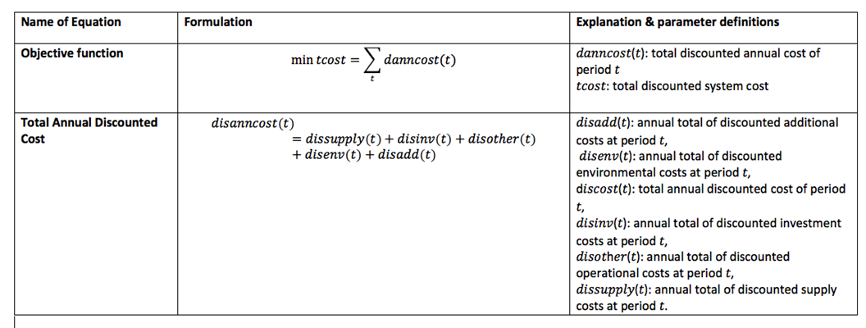

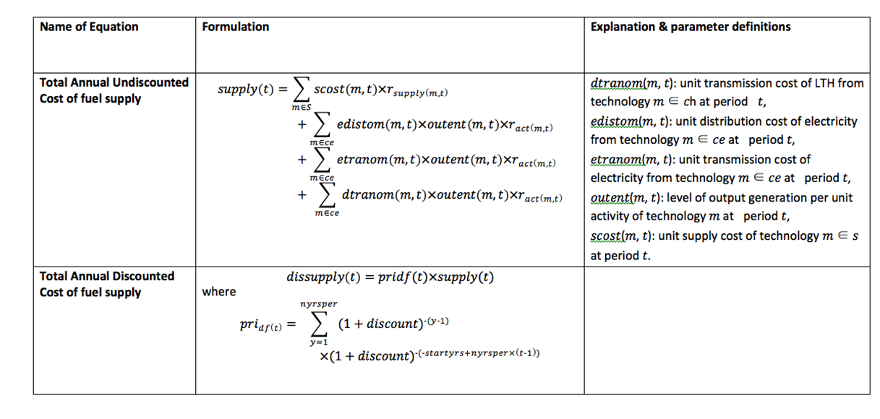

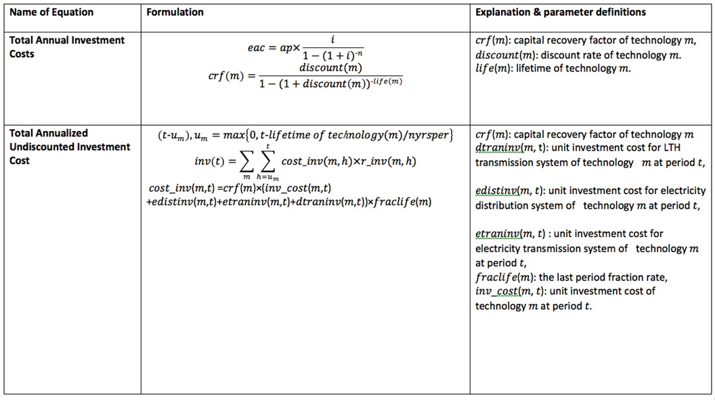

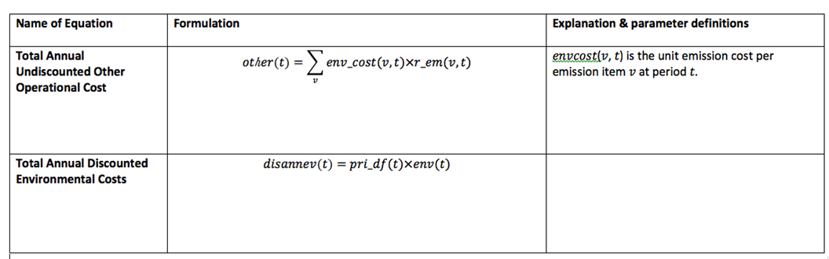

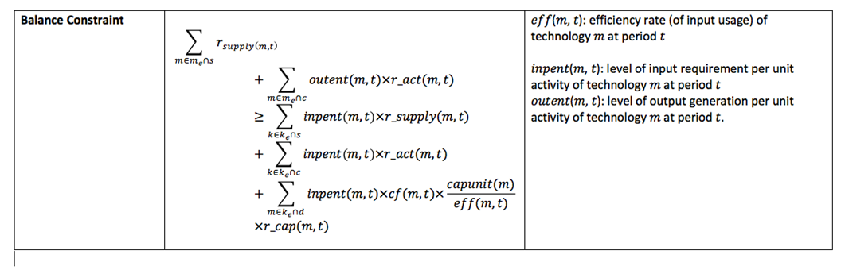

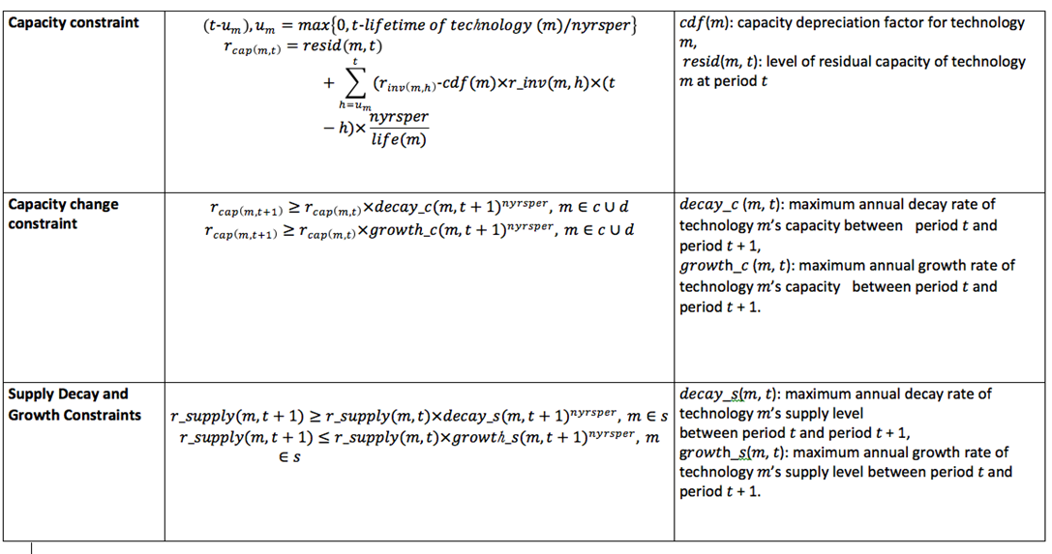

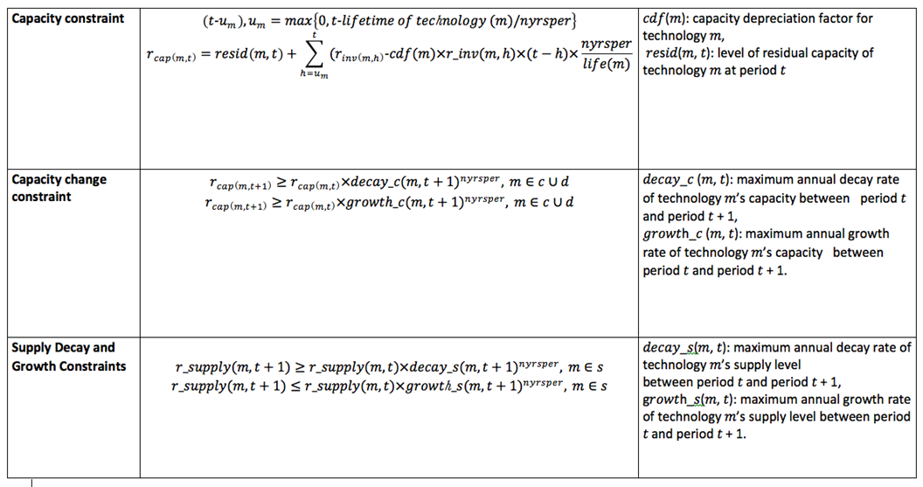

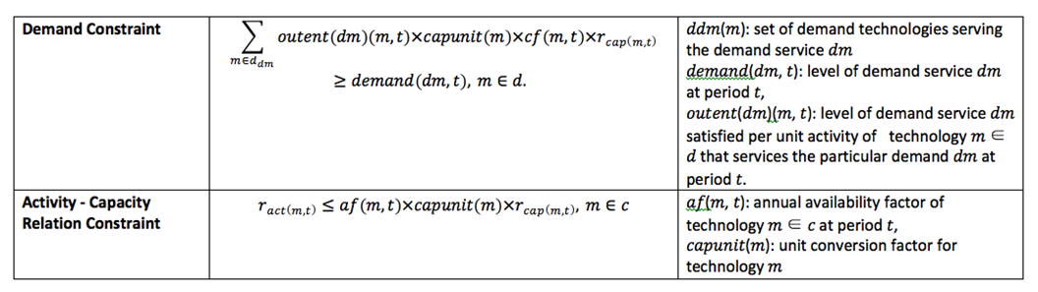

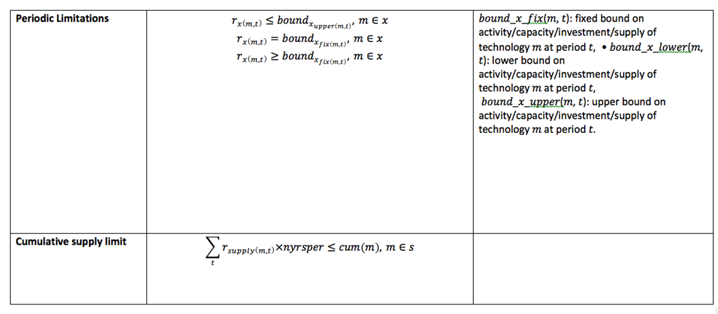

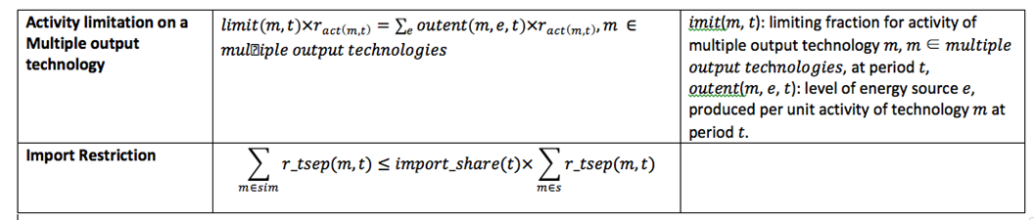

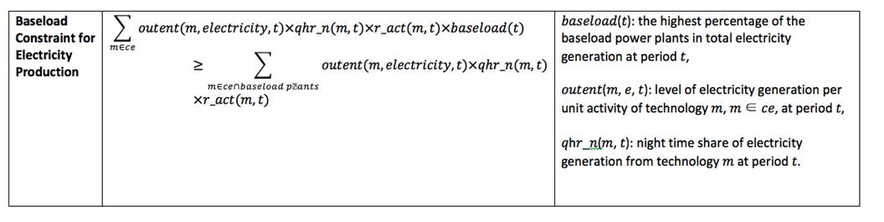

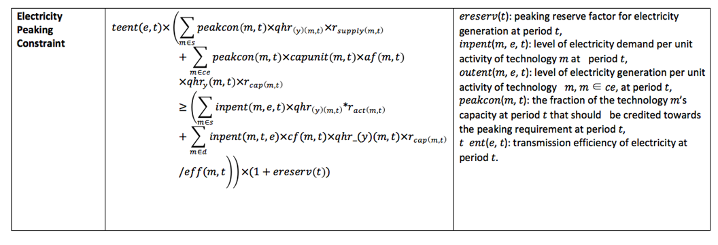

## 4.3.Pumped Hydro Storage - Hybrid Dams

Renewable energy such as wind or solar used to pump water uphill during times of low demand.When demand increases, or wind/solar production drops,water runs downhill from upper reservoir.Water run through turbine , creating electricity.More stable,less variable supply results from adding electricity turbine to original renewable power.Dams that are using pumped hydro storage are called hybrid dams.It is increasing the initial investment cost 20-25 percent and capacity %19-21 percent.

(<http://large.stanford.edu/courses/2014/ph240/galvan-lopez2/>)

## 4.4.Development of Alternative Solutions

### 4.4.1.Case 1:

The current model that has no ability to represent climate change effect.Capacities are fixed.Also seasonality for the winter and summer periods is not represented in a correct way.Regular dam technologies are used in the model.

### 4.4.2.Case 2.1:

The model that forecasting results are implemented.Capacities are reduced.Also seasonality for the winter and summer included to the model.Reduction in flows is 2.05% per five years for this case.Regular dam technologies are used in the model.

### 4.4.3.Case 2.2:

The model that forecasting results are implemented.Capacities are reduced.Also seasonality for the winter and summer included to the model.Reduction in flows is 3.07% per five years for this case.Regular dam technologies are used in the model.

### 4..4.Case 3.1:

The model that forecasting results are implemented.Capacities are reduced.Also seasonality for the winter and summer included to the model.Reduction in flows is 2.05% per five years for this case.Regular dam technologies are changed with pumped-storage hybrid dams which has higher capacity and investment cost.

### 4.4.5.Case 3.2:

The model that forecasting results are implemented.Capacities are reduced.Also seasonality for the winter and summer included to the model.Reduction in flows is 3.07% per five years for this case.Regular dam technologies are changed with pumped-storage hybrid dams which has higher capacity and investment cost.

|  |  |
| --- | --- |
| Case 1 | Fixed Flow + Regular Dam |
| Case 2.1 | 2.05% Flow Reduction per 5 years + Regular Dam Technology Model |
| Case 2.2 | 3.07% Flow Reduction per 5 years + Regular Dam Technology Model |
| Case 3.1 | 2.05% Flow Reduction per 5 years + Hybrid Dam Technology Model |
| Case 3.2 | 3.07% Flow Reduction per 5 years + Hybrid Dam Technology Model |

# 5.COMPARISON OF ALTERNATIVES AND RECOMMENDATIONS

|  |  |
| --- | --- |
| Case 1 | 184290.148378 |
| Case 2.1 | 184443.054435 |

2.05% Water Flow Reduction causes 152.9061 million dollars increase in total energy cost for Turkey in next 40 years

|  |  |
| --- | --- |
| Case 1 | 184290.148378 |
| Case 2.1 | 184443.054435 |
| Case 2.2 | 184512.693763 |

3.07% Water Flow Reduction causes 222.5454 million dollars increase in total energy cost for Turkey in next 40 years.

|  |  |
| --- | --- |
| Case 1 | 184290.148378 |
| Case 2.1 | 184443.054435 |
| Case 2.2 | 184512.693763 |
| Case 3.1 | 184453.330766 |

If there is a 2.05% Water Flow Reduction , hybrid dams with pump storage tech is not profitable due to high investment cost.Optimization of energy demand with regular dams 10.763 million dollars cheaper than hybrid ones.

|  |  |
| --- | --- |
| Case 1 | 184290.148378 |
| Case 2.1 | 184443.054435 |
| Case 2.2 | 184512.693763 |
| Case 3.1 | 184453.330766 |
| Case 3.2 | 184479.599128 |

If there is a 3.07% water flow reduction , hybrid dams with pump storage tech is profitable.Optimization of energy demand with hybrid dams 33.0946 million dollars cheaper than regular ones.Hybrid dams are more profitable when there is higher reduction in water flow.

|  |  |
| --- | --- |
| Case 1 | 1190500 |
| Case 2.1 | 1221800 |

2.05% Water Flow Reduction causes 152.9061 million dollars increase in total energy cost for Turkey in next 40 years.

|  |  |
| --- | --- |
| Case 1 | 1190500 |
| Case 2.1 | 1221800 |
| Case 2.2 | 1223900 |

3.07% Water Flow Reduction causes 222.5454 million dollars increase in total energy cost for Turkey in next 40 years.

|  |  |
| --- | --- |
| Case 1 | 1190500 |
| Case 2.1 | 1221800 |
| Case 2.2 | 1223900 |
| Case 3.1 | 1176200 |

If there is a 2.05% Water Flow Reduction , hybrid dams with pump storage tech is not profitable due to high investment cost.Optimization of energy demand with regular dams 10.763 million dollars cheaper than hybrid ones.

|  |  |
| --- | --- |
| Case 1 | 1190500 |
| Case 2.1 | 1221800 |
| Case 2.2 | 1223900 |
| Case 3.1 | 1176200 |
| Case 3.2 | 1190500 |

If there is a 3.07% water flow reduction , hybrid dams with pump storage tech is profitable.Optimization of energy demand with hybrid dams 33.0946 million dollars cheaper than regular ones.Hybrid dams are more profitable when there is higher reduction in water flow.

# 6.SUGGESTIONS FOR A SUCCESSFUL IMPLEMENTATION

In this study, we used important data that affect our daily life in all the steps of our work. A wide range of climate and soil information was needed for the dam area, especially when using the first stage ArcSWAT tool. As we have already mentioned, it is time consuming to find information about the dam area because there are not too many training documents about the ArcSWAT tool, and it is a great effort. As a result of our work, we have a good result and the applicability of the subject is possible. It is possible to realize a more efficient energy production by applying the results obtained from our study on the dam, which is currently continuing energy production. Since we are interested in the effects of climate change in our study, it is necessary to pass a long process to revise the data. The impact of climate change is not a situation that can be observed in a very short time, but requires time.

The design we have obtained as a result of the study can be applied in Atatürk Dam. After this work is carried out for different dams Turkey's overall energy efficiency can be increased. Turkey hydro power installation with respect although production should use the existing potential in the best way. For this, the efficiency of existing dams should be increased. This work is evaluated as an exemplary project and determined in the future steps in terms of energy efficiency and thus a more determined policy is followed in terms of energy production and consumption.

# 7.CONCLUSION AND DISCUSSION

We have made some important steps in using the industrial engineering perspective. First we estimated the flow data we have for the future. Predicting a knowledge for the future is guiding us in terms of future decisions. Since climate change depends on many parameters, it is a difficult responsibility to clearly mention a future estimate. We tried to take into account a parameter that could give us more effective results in the forecast stage. We have chosen to observe the flow data as the flow data is a parameter that can directly observe climate change and directly affect the production of hydroelectric power in dams. We predicted the x, y, z and t information for the future because these data was our future-oriented data and influenced the flow data. As a result of the estimates in these data, we observed the percentage decrease in the flow data. As the decrease in flow data directly affected the production of hydroelectric power, this result was a sign that the production of hydroelectric power would decrease with decreasing flow.

We used the other important industrial engineering perspective on the BUEMS model. As it is important to increase the efficiency in the production of hydropower, we have dealt with the situations that may occur in the existing hydro energy production site. For this, we calculated the percentage change data obtained in the BUEMS model and observed the change in cost. The purpose of the BUEMS model is to minimize the entire system cost. In this step it is possible to see the solution of an optimization problem. In order to reduce the negative effects of climate change in a hydropower production area, a cost-benefit assessment and a CO2 evaluation were made. When a change was made in the existing hydroelectricity site, we made a study about what this cost would be. We have added a new technology, pump storage technology, to the BUEMS model. We observed the situation of these on the Atatürk Dam and observed the effects of climate change on the production of hydroelectric power in the coming years.

This study may play an important role in making future decisions by observing the impact of the proposed climate change on the production of hydroelectric power. Dangers on dams with existing hydroelectric resources can be identified and planned to minimize them. In this respect, this study will be an example. The data obtained from this study can be applied to dams that produce hydro energy. In the future, it is important to take measures against the decrease in hydroelectric production.

**https://gadm.org/download_country_v2.html**

**https://globalweather.tamu.edu/**

**https://earthexplorer.usgs.gov/**

**https://forobs.jrc.ec.europa.eu/products/glc2000/products.php**

**http://srtm.csi.cgiar.org/download/**

**https://clearinghouse.isgs.illinois.edu/data/land-cover/usda-nass-cropland-data-layer-illinois-2007**

[**https://soilgrids.org/#!/?lon=37.2869203898043&lat=37.476703399592&layer=ORCDRC_M_sl2_250m&vector=1&showInfo=1**](https://soilgrids.org/#!/?lon=37.2869203898043&lat=37.476703399592&layer=ORCDRC_M_sl2_250m&vector=1&showInfo=1)

# References

1. The impact of climate change on hydropower generation in Rio Jubones Basin. **Mohammad Mehedi Hasan,** . Ecuador : s.n., 5 July 2018.

2. Modeling the effects of climate change on hyroelectric power in Dokan. **Petter Pilesjo, Sameer Sadoon Al-Juboori**. Iraq : s.n., 10 October 2015.

4. https://gadm.org/download_country_v2.html. [Online]

5. https://globalweather.tamu.edu/. [Online]

6.

1.Mohammad Mehedi Hasan, Guido Wyseure, 5 July 2018, *The impact of climate change on hydropower generation in Rio Jubones* *Basin*, Ecuador.